Banking Transaction Trends and Financial Activity Insights for Customer Analysis
Abstract
Banking activities produce important patterns about how customers manage money through regular deposits, withdrawals, and account transactions over time. This project examines financial records to understand how transaction behavior changes across different periods and how customers interact with banking services through various types of monetary activity. It considers details such as transaction dates, descriptions, cheque references, deposit amounts, withdrawal amounts, and account balance to identify meaningful movement in account operations. The analysis helps in observing periods of higher financial activity, differences between incoming and outgoing transactions, and the overall flow of money within customer accounts. It also provides insight into how balance levels change based on transaction frequency and transaction type. By studying these trends, the project presents a clearer understanding of customer financial behavior and highlights important patterns in day-to-day banking activity.

2. INTRODUCTION
Banking plays a central role in the financial structure of society by enabling individuals and organizations to store, transfer, and manage money securely. Every day, a large number of financial transactions take place in the form of deposits, withdrawals, cheque payments, and other account activities. These transactions are recorded systematically, creating a continuous flow of financial data that reflects how customers interact with banking services over time. Understanding this transactional data is essential for identifying patterns in financial behavior and gaining insights into how money is managed within accounts.
With the rapid growth of digital banking and electronic transactions, the volume of financial data has increased significantly. Each transaction carries important information such as date, type of transaction, amount, and resulting balance. When observed individually, these records may appear simple, but when analyzed collectively, they reveal meaningful patterns related to spending habits, saving tendencies, and overall financial activity. This makes transaction data an important source of information for analyzing customer behavior.
The need to study banking transaction patterns arises from the importance of understanding how financial activities evolve over time. Customers may show different behaviors during different periods, such as increased withdrawals during certain months or higher deposits during specific time frames. Identifying such variations helps in recognizing trends and understanding the factors that influence financial decisions. It also allows for the observation of how account balances fluctuate based on transaction frequency and transaction type.
Another important aspect of this analysis is the distinction between incoming and outgoing transactions. Deposits represent inflow of money, while withdrawals indicate outflow. By comparing these two types of transactions, it becomes possible to understand whether an account is experiencing growth or decline over a period of time. This comparison also helps in identifying patterns such as consistent saving behavior or frequent spending, which are key indicators of financial activity.
Handling transactional data effectively requires a structured approach. Raw data often contains inconsistencies such as missing entries, repeated records, or irregular formatting. Before performing any analysis, it is necessary to organize and clean the data to ensure accuracy and reliability. This step helps in preparing the dataset for meaningful interpretation and prevents incorrect conclusions from being drawn.
Once the data is properly structured, analytical techniques can be applied to examine trends and relationships within the dataset. Basic data handling tools are used to filter, sort, and aggregate the data, making it easier to study transaction patterns across different time periods. These techniques help in identifying high activity periods, measuring transaction volumes, and understanding how balances change over time.
Visualization plays an important role in making the analysis more understandable. Instead of relying only on numerical values, graphical representations help in clearly identifying trends and patterns. Simple charts and plots can be used to display transaction counts, total deposits, total withdrawals, and balance variations. These visualizations provide a quick and effective way to interpret complex data and communicate insights.
The importance of this analysis extends to several real world applications. In banking operations, understanding transaction trends helps in monitoring account activity and improving service efficiency. It allows financial institutions to identify periods of high workload and manage resources accordingly. For example, if certain days or months show increased transaction activity, appropriate measures can be taken to ensure smooth operations during those times.
From a customer perspective, analyzing transaction data provides valuable insights into personal financial behavior. It helps individuals understand their spending patterns, track their savings, and make better financial decisions. By observing how frequently money is deposited or withdrawn, customers can gain a clearer picture of their financial habits and plan accordingly.
In addition, transaction analysis supports better financial management by highlighting important patterns such as irregular activity or sudden changes in balance. These observations can be useful for maintaining financial stability and ensuring that account activity remains consistent over time. Identifying such patterns also helps in maintaining transparency and accuracy in financial records.
In this project, the focus is on examining banking transaction data to identify trends in financial activity and understand how customer behavior changes over time. The approach involves organizing the transaction records, analyzing key attributes such as transaction amounts and balance changes, and presenting the findings in a clear and structured manner. Wherever required, basic data handling and visualization tools are used to support the analysis and improve clarity.
Overall, this study emphasizes the importance of analyzing financial transactions to gain insights into money flow and customer behavior. By carefully examining transaction records, it becomes possible to uncover meaningful patterns that contribute to a better understanding of banking activity. This not only enhances the interpretation of financial data but also supports more informed decision making in both operational and personal financial contexts.

The existing system in this domain is based on maintaining banking transaction records in a simple Excel sheet. Customer account details and transaction information are manually entered into the spreadsheet, with columns such as account number, date, transaction details, cheque number, withdrawal amount, deposit amount, and balance amount.
This system is primarily used for basic data storage, where all transaction records are organized in tabular form. Users can view, update, and maintain records directly within the sheet as new transactions occur. Each row represents an individual transaction, allowing easy tracking of daily account activity.
The Excel based approach provides a straightforward way to store and access financial data without involving complex processes. It serves as a simple method for recording transactions and reviewing account details whenever required.

4. DISADVANTAGES OF EXISTING SYSTEM
- Manual Data Entry Errors
Since the system relies on manually entering transaction details into an Excel sheet, there is a high chance of human errors. Mistakes such as incorrect amounts, wrong dates, or misplaced entries can occur easily. Even small errors can affect balance calculations and lead to incorrect records, making the data unreliable over time.
- Time Consuming Process
Recording each transaction manually requires continuous effort and time. As the number of transactions increases, maintaining the sheet becomes more tedious. Updating records, verifying entries, and correcting mistakes can take significant time, especially when dealing with large datasets.
- Lack of Data Consistency
Without strict controls, data may not be entered in a consistent format. For example, transaction descriptions, date formats, or amount fields may vary across entries. This inconsistency makes it difficult to analyze the data properly and can lead to confusion while interpreting records.
- Difficulty in Handling Large Data Volumes
As the number of transactions grows, Excel sheets become larger and harder to manage. Scrolling through thousands of rows, filtering data, and locating specific records becomes inefficient. This limits the system’s ability to handle long term or large scale data effectively.
- Limited Data Retrieval Efficiency
Searching for specific information such as transactions within a date range or particular transaction types can be slow and cumbersome. Users often need to apply multiple filters or manually scan through rows, which reduces efficiency in accessing required data.
- Higher Chances of Data Duplication
Manual handling increases the possibility of duplicate entries. The same transaction may be recorded more than once due to oversight, leading to incorrect totals and misleading analysis. Detecting and removing duplicates also requires additional effort.
- Lack of Structured Data Management
Excel sheets store data in a flat format without enforcing relationships between different data elements. This makes it difficult to maintain organized and structured records, especially when dealing with multiple accounts or complex transaction details.
- Difficulty in Tracking Changes
It is hard to monitor who made changes to the data and when those changes were made. If an incorrect entry is modified or deleted, there may not be a clear record of the update, making it difficult to track data history and maintain accuracy.
- Limited Analytical Capability
While basic calculations can be performed, performing detailed analysis directly within the sheet is not efficient. Identifying patterns, trends, or comparisons across different periods requires additional effort and manual calculations.
- Risk of Data Loss
Storing all records in a single Excel file increases the risk of data loss due to file corruption, accidental deletion, or system failure. Without proper backups, important transaction data may be permanently lost.
- Difficulty in Multi User Access
When multiple users need to access or update the same file, it can lead to conflicts or version issues. Changes made by one user may overwrite another user’s updates, causing inconsistencies in the data.
- Inefficient for Real Time Updates
The system does not support real time updates effectively. Transactions need to be entered manually after they occur, which means the data may not always reflect the current state of account activity.
- Poor Data Visualization
The existing system mainly focuses on storing data rather than presenting it in an easily understandable format. Users must rely on raw tables instead of clear visual representations, making it harder to quickly interpret trends and patterns.
- Difficulty in Maintaining Data Accuracy Over Time
As the dataset grows and multiple updates are made, maintaining accuracy becomes challenging. Small inconsistencies and unnoticed errors can accumulate over time, reducing the overall quality and reliability of the data.
- Limited Scalability for Future Needs
The system is not designed to expand efficiently as data grows or requirements increase. Managing larger datasets or performing more detailed analysis becomes increasingly difficult, making it less suitable for long term use.

5. PROPOSED SYSTEM

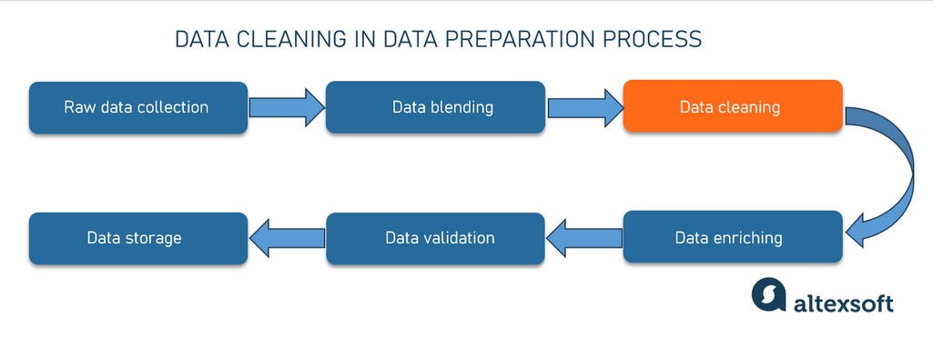

The proposed system introduces a structured and organized approach to handling banking transaction data by transforming raw records into a clean, consistent, and analysis ready dataset. Instead of relying only on basic data storage, this system focuses on improving data organization, accuracy, and usability for better analysis and reporting.
In this system, the raw transaction data is first collected in a tabular format containing fields such as account number, date, transaction details, cheque number, value date, withdrawal amount, deposit amount, and balance amount. The data is then processed to ensure consistency and correctness before further use.
Data Processing and Structuring
The first step in the proposed system is data cleaning and preprocessing. This involves handling missing values, correcting inconsistent formats, and removing duplicate entries. Dates are standardized into a uniform format, and numerical columns such as withdrawal and deposit amounts are properly structured to ensure accurate calculations.
Additional columns are then created to enhance the dataset and make analysis easier. These include:
- Transaction Type
Each transaction is classified as either deposit or withdrawal based on the values present.
- Net Amount
A new column is created to represent the actual impact of the transaction. Deposits are treated as positive values, while withdrawals are treated as negative values.
- Balance Status
This indicates whether the account balance remains positive after each transaction.
- High Value Indicator
Transactions above a certain threshold are marked to identify significant financial activity.
- Date Based Columns
The date field is further broken down into year, month, and day to support time based analysis.
This structured transformation converts raw data into a well organized dataset that is easier to analyze and interpret.
Logical Flow of the System
The system follows a clear and step by step workflow:
- Data is collected from transaction records
- Raw data is cleaned and standardized
- Derived columns are created for better understanding
- Data is organized into a structured format
- Analytical operations are performed to identify patterns
- Results are presented using visual representations
This logical flow ensures that the data moves from an unstructured state to a meaningful and analysis ready format.
Analytical Approach
The proposed system focuses on extracting insights from transaction data by analyzing patterns such as:
- Frequency of deposits and withdrawals
- Daily and monthly transaction activity
- Variations in account balance over time
- Identification of high value transactions
- Comparison between inflow and outflow of money
Instead of manually scanning records, the system allows quick identification of trends through organized data and simple analytical methods.
Role of Technologies Used
Basic data handling tools are used during the preprocessing stage to clean and transform the dataset efficiently. These tools help in performing operations such as filtering, grouping, and calculating new columns.
For analysis, structured queries are used wherever necessary to extract specific insights from the dataset. This allows efficient handling of large volumes of data and simplifies the process of retrieving required information.
Visualization tools are used to present the analyzed data in the form of charts and dashboards. These visual representations help in understanding patterns quickly and make the insights more clear and accessible.
Improvements Over Existing System
The proposed system significantly improves the way banking transaction data is handled:
- Data is no longer just stored but properly structured for analysis
- Errors are reduced through systematic cleaning and validation
- Additional fields provide deeper insights into transaction behavior
- Large volumes of data can be managed more efficiently
- Data retrieval and analysis become faster and more organized
- Visual representation improves understanding of trends
Real Time Understanding of Financial Activity
By organizing and analyzing transaction data in a structured manner, the system provides a clear view of how financial activity changes over time. Users can easily track spending patterns, monitor deposits, and observe balance fluctuations without manually reviewing each record.
Overall System Perspective
The proposed system transforms a simple record keeping approach into a more structured and analytical process. It ensures that transaction data is accurate, consistent, and ready for analysis. By combining proper data handling, logical structuring, and clear visualization, the system enables better understanding of banking activities and supports more informed decision making.

6. ADVANTAGES OF PROPOSED SYSTEM
- Improved Accuracy in Data Handling
The proposed system ensures higher accuracy by applying proper data cleaning and structuring techniques before analysis. Inconsistent formats, missing values, and duplicate records are handled systematically, reducing the chances of errors. Calculated fields such as net amount and transaction type are derived using clear logic, which minimizes manual mistakes and ensures reliable results. This leads to more trustworthy insights and better data quality over time.
- Higher Efficiency in Data Processing
Compared to manual handling, the system processes large volumes of transaction data quickly and efficiently. Tasks such as sorting, filtering, and aggregating data are performed in a structured manner, saving significant time and effort. Instead of manually reviewing each record, users can easily access summarized information and key metrics, making the overall workflow faster and more productive.
- Automation of Repetitive Tasks
The system automates several repetitive operations such as data cleaning, column creation, and basic calculations. For example, identifying transaction type, computing net amount, and extracting year, month, and day from date fields are done automatically. This reduces the need for continuous manual intervention and ensures consistency in how data is processed. Automation also helps maintain uniformity across the dataset.
- Better Data Organization and Structure
The introduction of additional columns and standardized formats results in a well organized dataset. Each transaction is clearly defined with meaningful attributes, making it easier to understand and analyze. Structured data improves readability and ensures that all relevant information is available in a consistent manner, which supports effective analysis.
- Scalability for Large Datasets
The proposed system is designed to handle increasing volumes of data efficiently. As more transaction records are added over time, the system can manage them without significant performance issues. Structured storage and organized processing make it easier to scale the system for larger datasets, ensuring long term usability.
- Faster Data Retrieval and Analysis
With organized data and structured logic, retrieving specific information becomes much easier. Users can quickly access required details such as transactions within a particular period or specific types of transactions. This improves the speed of analysis and helps in making quicker decisions based on the data.
- Enhanced Analytical Capability
The system supports deeper analysis by introducing meaningful derived columns and enabling structured data exploration. It becomes easier to identify patterns such as frequent withdrawals, high value transactions, and balance trends. This allows users to gain more insights compared to simple data storage methods.
- Clear Visualization of Data
By presenting the processed data through charts and dashboards, the system makes it easier to understand complex information. Visual representation helps in identifying trends, comparisons, and patterns quickly, which improves overall interpretation of the data.
- Consistency in Data Processing
Since the system follows a defined workflow for data handling, all records are processed in a consistent manner. This ensures uniformity in calculations and data representation, reducing confusion and improving reliability.
- Reduction in Manual Effort
The need for manual data entry, verification, and correction is significantly reduced. Most of the processing steps are handled systematically, allowing users to focus more on analysis rather than data preparation.
- Real World Applicability
The system can be effectively used in real world scenarios where large volumes of financial data need to be managed and analyzed. It supports better monitoring of transaction activity, helps in understanding customer behavior, and improves overall financial tracking.
- Better Decision Making Support
By providing accurate and well organized data along with clear insights, the system supports informed decision making. Users can rely on the analysis to understand financial patterns and take appropriate actions based on observed trends.
- Improved Data Reliability Over Time
With proper validation and structured processing, the quality of data remains consistent even as the dataset grows. This ensures that long term analysis remains accurate and dependable.
- Simplified Workflow Management
The step by step process from data collection to analysis creates a smooth and manageable workflow. Each stage is clearly defined, making the system easy to use and maintain.
- Adaptability to Different Data Requirements
The system can be easily adjusted to accommodate additional fields or new types of analysis. This flexibility allows it to be used for various types of transaction datasets without major changes.

7. INTRODUCTION TO APPLICATION
The application developed in this project is a structured data analysis system designed to process and analyze banking transaction records. It focuses on transforming raw financial data into a clean and organized format, enabling users to understand transaction patterns, monitor account activity, and observe financial trends over time. The system is built to handle transaction level data efficiently and present meaningful insights in a clear and understandable manner.
What the System Does
The system takes raw transaction data as input and processes it through a series of steps to make it suitable for analysis. It organizes transaction records, standardizes formats, and generates additional fields that help in understanding financial activity. The application identifies whether a transaction is a deposit or withdrawal, calculates the net impact of each transaction, and tracks how the account balance changes over time.
It also enables users to analyze transaction behavior across different time periods by breaking down date information into year, month, and day. This allows for detailed observation of patterns such as daily activity, monthly trends, and overall financial flow within the account.
Key Features
- Data Cleaning and Preparation
The application ensures that raw data is cleaned and formatted properly before analysis. This includes handling missing values, correcting inconsistencies, and organizing the dataset.
- Automatic Column Generation
Additional columns such as transaction type, net amount, balance status, and time based attributes are created automatically to enhance the dataset.
- Transaction Classification
Each transaction is clearly categorized as deposit or withdrawal, making it easier to analyze inflow and outflow of money.
- Time Based Analysis
The system enables analysis based on different time levels such as daily, monthly, and yearly trends.
- Structured Data Organization
All records are maintained in a well organized format, allowing easy access and understanding of transaction details.
- Basic Visualization Support
The application supports simple visual representation of data to highlight patterns and trends.
User Interaction
The system is designed to be simple and user friendly. Users interact with the application by providing the transaction dataset as input. Once the data is loaded, the system automatically processes it without requiring complex manual steps.
Users can view the cleaned dataset, observe newly generated columns, and explore transaction patterns through organized tables and visual outputs. Interaction mainly involves reviewing results, applying basic filters if needed, and interpreting the displayed information.
Data Flow Through the System
The application follows a clear and logical flow of data:
- Raw transaction data is provided as input
- Data is cleaned and standardized
- New columns are generated based on defined logic
- The dataset is structured for analysis
- Analytical operations are performed to identify trends
- Results are presented in tabular and visual formats
This step by step flow ensures that data moves smoothly from its raw state to a meaningful and analysis ready form. Each stage adds value to the data, improving its quality and usability.
Overall, the application provides a complete framework for handling banking transaction data. It not only simplifies data management but also enhances the ability to analyze and understand financial activity in a structured and efficient manner.

8. BLOCK DIAGRAM
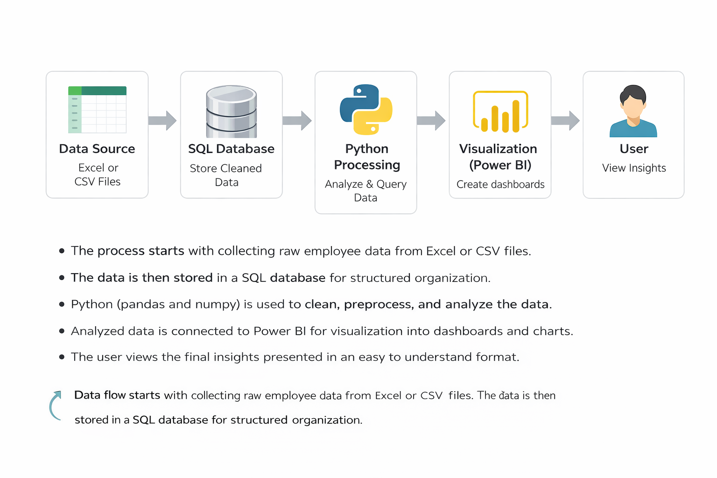
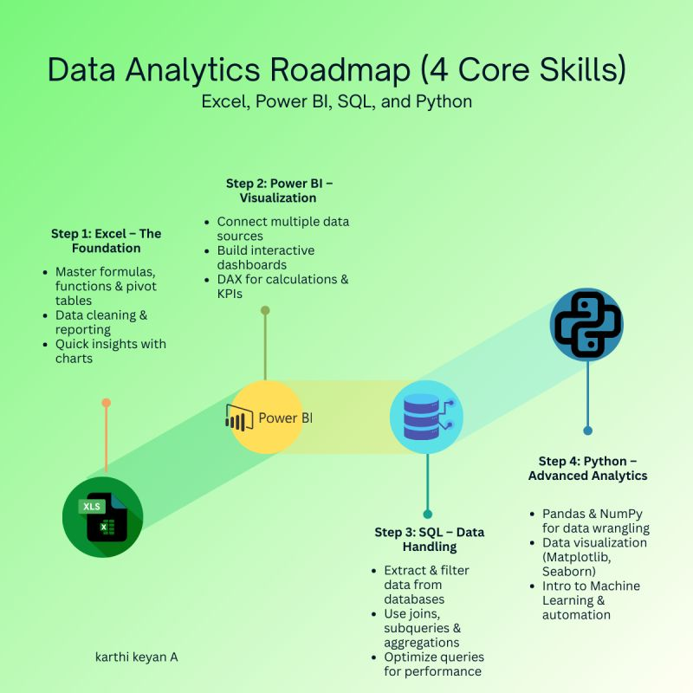
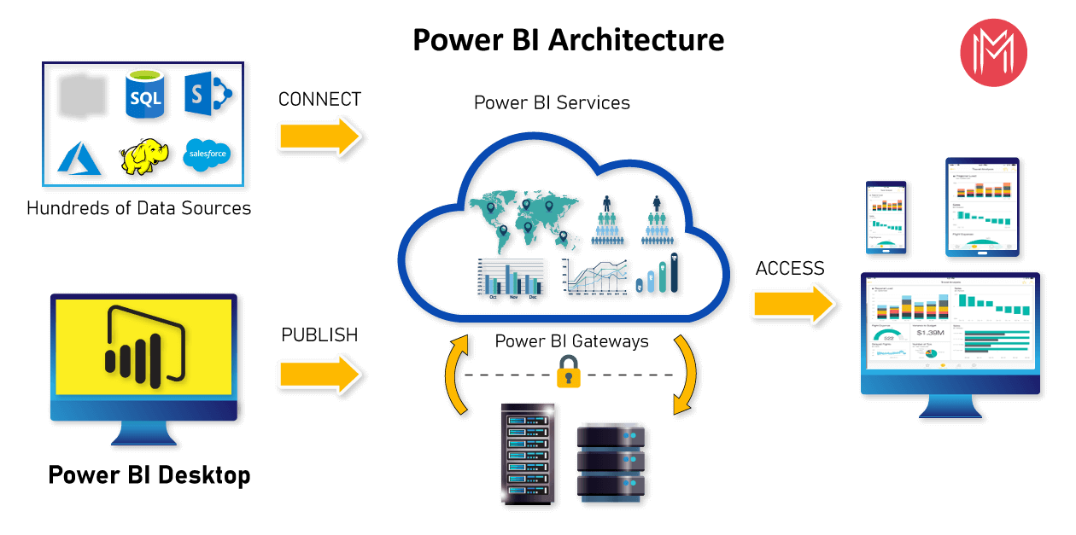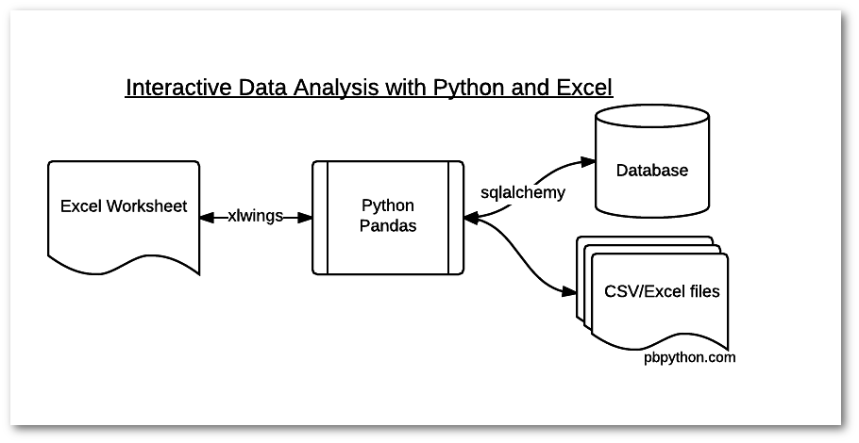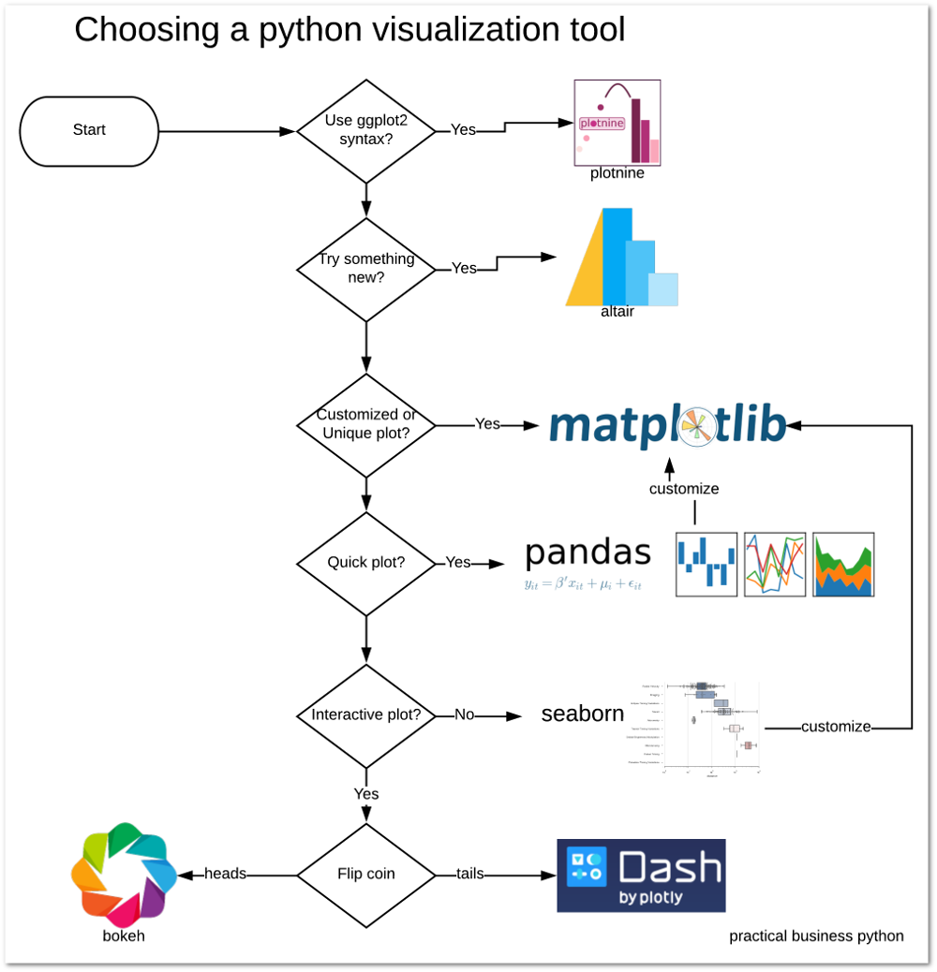
Explanation of Each Block
Data Source
This is the starting point of the system. It contains raw banking transaction data collected in the form of Excel or CSV files. The data includes fields such as account number, date, transaction details, withdrawal amount, deposit amount, and balance.
SQL Database
The cleaned or prepared data is stored in a structured format inside the database. This helps in organizing the data properly and allows efficient storage and retrieval of transaction records when needed.
Python Processing
In this stage, the data is processed and transformed. Cleaning operations are performed, new columns such as transaction type and net amount are created, and the dataset is prepared for analysis. This step ensures the data is accurate and ready for further use.
Visualization (Power BI)
The processed data is connected to visualization tools to create charts, graphs, and summary views. This helps in understanding transaction trends, comparing deposits and withdrawals, and observing balance changes in an easy and clear way.
User
The final output is presented to the user. The user views the dashboards, analyzes the results, and understands the financial patterns through the visual representations.
Data Flow Explanation
The process starts with collecting raw transaction data from the data source. This data is then organized and stored in a database for better structure. After that, the data is processed to clean and enhance it by adding useful information. Once the data is ready, it is visualized using charts and dashboards. Finally, the user interacts with these outputs to understand the insights and make decisions based on the analysis.

9. DATA ANALYTICS SECTION
9.1 Overview
Data analytics refers to the process of examining raw data in order to extract meaningful information, identify patterns, and support decision making. It involves organizing, processing, and analyzing data to convert it into useful insights. In the context of this project, data analytics is used to study banking transaction records and understand how financial activities change over time.
In this project, transaction data such as deposits, withdrawals, and account balances is analyzed to observe patterns in customer financial behavior. Instead of simply storing records, data analytics helps in identifying trends such as frequent transactions, variations in balance, and differences between inflow and outflow of money. This makes the data more useful and meaningful.
Data analytics plays an important role in improving the understanding of financial activity. By analyzing transaction data, it becomes possible to track how accounts are used, identify periods of high activity, and observe how balances are maintained. This helps in gaining a clear picture of how money flows within an account and supports better interpretation of financial records.
There are different types of analytics that are applied in this project:
- Descriptive Analytics
This type focuses on understanding what has already happened in the data. It includes summarizing transaction records, calculating totals of deposits and withdrawals, and observing balance trends. In this project, descriptive analytics is used to present an overall view of financial activity.
- Diagnostic Analytics
This type helps in understanding why certain patterns occur. For example, if there is a sudden increase in withdrawals during a specific period, diagnostic analysis helps in examining the reason behind that change by comparing related data.
- Predictive Analytics
This type involves identifying possible future trends based on past data patterns. In this project, basic observations can indicate how transaction behavior might continue, such as consistent spending or saving patterns over time.
- Prescriptive Analytics
This type focuses on suggesting actions based on the analysis. By understanding transaction patterns, it becomes possible to make better financial decisions, such as controlling spending or maintaining a stable balance.
In this project, the primary focus is on descriptive and diagnostic analytics, as they help in clearly understanding transaction behavior and identifying patterns in financial data. The use of structured data and simple analytical methods ensures that insights are easy to interpret and useful for practical understanding.
Overall, data analytics transforms raw banking transaction data into meaningful information. It helps in identifying trends, understanding financial behavior, and presenting insights in a clear and organized manner, making the data more valuable and easier to work with.
9.2 Data Description
The dataset used in this project consists of banking transaction records that capture detailed information about customer account activities. Each row in the dataset represents a single transaction, and each column provides specific details related to that transaction. The data is structured in a tabular format, making it suitable for processing and analysis.
Description of Columns
- Account Number
This column represents the unique identifier of the customer account. It is used to distinguish transactions belonging to different accounts. The data type is generally numeric or string depending on formatting.
- Date
This column indicates the date on which the transaction occurred. It is a time based field and is essential for analyzing transaction patterns over different periods. The data type is date or datetime.
- Transaction Details
This field contains a description of the transaction, such as payment type, transfer details, or service reference. It is a text field and helps in understanding the nature of each transaction.
- Cheque Number
This column stores the cheque reference if the transaction involves a cheque. If not applicable, it may contain a default value such as "No Cheque". The data type is string.
- Value Date
This represents the date when the transaction is officially processed or settled. It is useful for tracking actual financial impact timing. The data type is date or datetime.
- Withdrawal Amount
This column shows the amount of money withdrawn from the account. It contains numeric values and represents outgoing transactions.
- Deposit Amount
This column shows the amount of money deposited into the account. It contains numeric values and represents incoming transactions.
- Balance Amount
This indicates the account balance after each transaction. It is a numeric field and helps in tracking how the balance changes over time.
- Transaction Type
This is a derived column that classifies each transaction as either deposit or withdrawal based on the values in the amount columns. It is a categorical field.
- Net Amount
This column represents the actual impact of the transaction on the account. Deposits are treated as positive values and withdrawals as negative values. It is a numeric field used for analysis.
- Balance Status
This indicates whether the account balance remains positive after each transaction. It is a categorical field, typically showing values such as positive.
- High Value Indicator
This column identifies whether a transaction exceeds a certain threshold. It is useful for highlighting significant transactions. The data type is categorical.
- Year
Extracted from the date column, this field represents the year of the transaction. It is used for yearly analysis. The data type is numeric.
- Month
This column represents the month of the transaction, either as a name or number. It supports monthly trend analysis. The data type is categorical or numeric.
- Day
This column represents the day of the transaction. It is useful for detailed time based analysis. The data type is numeric.
Relevance of the Dataset
The dataset is highly relevant for analyzing banking transaction behavior. It provides a complete view of financial activity by capturing both inflow and outflow of money along with balance updates. The presence of both original and derived columns allows for deeper analysis without requiring complex transformations during later stages.
By combining transaction details with time based attributes, the dataset supports analysis at different levels such as daily, monthly, and yearly trends. It also enables comparison between deposits and withdrawals, helping to understand financial patterns clearly.
Overall, the dataset is well structured and contains all necessary attributes required for performing meaningful analysis of banking transactions.
9.3 Data Preprocessing
Data preprocessing is an essential step in this project, as it ensures that the raw banking transaction data is clean, consistent, and ready for analysis. The original dataset may contain inconsistencies, missing values, and formatting issues that need to be addressed before performing any analytical operations. The preprocessing stage transforms raw data into a structured and reliable format.
Data Cleaning
Data cleaning involves identifying and correcting errors in the dataset. Duplicate records are removed to avoid repeated transactions affecting the analysis. Inconsistent entries in columns such as transaction details or cheque numbers are standardized to maintain uniformity. Unnecessary spaces, incorrect text formats, and invalid entries are corrected to ensure that the data is accurate and consistent across all records.
Handling Missing Values
Some fields in the dataset may have missing or empty values, especially in columns like cheque number, withdrawal amount, or deposit amount. These missing values are handled carefully to maintain data integrity. For example, if a transaction does not involve a cheque, a default value such as "No Cheque" is assigned. Similarly, missing numeric values in withdrawal or deposit columns are replaced with zero where appropriate, ensuring that calculations remain correct.
Data Formatting
Proper formatting is applied to ensure consistency in data types and structure. Date columns are converted into a standard date format to support time based analysis. Numeric columns such as withdrawal amount, deposit amount, and balance are converted into appropriate numeric types to enable calculations. Text fields are formatted uniformly to avoid inconsistencies during filtering and grouping operations.
Feature Engineering
Feature engineering is used to create additional columns that enhance the dataset and make analysis more effective. New fields are derived from existing data using simple logic:
- Transaction Type is created to classify each record as deposit or withdrawal
- Net Amount is calculated to represent the actual impact of the transaction
- Balance Status indicates whether the account balance remains positive
- High Value Indicator identifies transactions above a defined threshold
- Year, Month, and Day are extracted from the date column for time based analysis
These additional features provide more context and make it easier to analyze transaction patterns without requiring repeated calculations.
Overall, data preprocessing ensures that the dataset is accurate, complete, and well structured. By cleaning, organizing, and enhancing the data, this step lays the foundation for effective analysis and meaningful insights.

9.4 Exploratory Data Analysis EDA
Exploratory Data Analysis is performed to understand the underlying patterns, trends, and distributions present in the banking transaction dataset. This stage focuses on examining the data in detail to identify how financial activities vary over time and how different transaction components interact with each other. It helps in building a clear understanding of the dataset before drawing conclusions.
Transaction Patterns
The analysis of transaction records shows a clear distinction between deposit and withdrawal activities. In most cases, withdrawals occur more frequently compared to deposits, indicating regular spending behavior. Deposits, on the other hand, appear less frequent but involve higher amounts in certain cases, suggesting periodic inflow of funds rather than continuous deposits.
Another noticeable pattern is that transactions are not evenly distributed across all days. Some days show multiple transactions, while others have little or no activity. This variation highlights that financial activity is often clustered around specific dates rather than being uniform.
Trends Over Time
When observing the data over time, trends can be identified in both transaction frequency and transaction amounts. Certain periods show increased financial activity, which may correspond to salary credits, bill payments, or other routine financial events. These periods are characterized by a combination of deposits followed by multiple withdrawals.
Monthly analysis reveals that transaction behavior tends to follow a cycle. At the beginning of a period, deposits may increase the account balance, followed by a gradual decrease due to continuous withdrawals. This creates a repeating pattern of rise and fall in the balance over time.
Balance Behavior
The account balance shows a fluctuating trend based on transaction activity. Large deposits result in a sudden increase in balance, while frequent withdrawals cause a steady decline. The balance does not change randomly but follows a logical pattern driven by transaction type and frequency.
In most cases, the balance remains positive, indicating stable account management. However, variations in balance levels provide insights into how actively the account is being used and how funds are managed across different periods.
Distribution of Transaction Amounts
The distribution of transaction amounts shows that most transactions fall within a moderate range, while a few transactions have significantly higher values. These high value transactions stand out clearly and represent important financial events such as large transfers or bulk payments.
Withdrawals are often distributed across a wider range of values, reflecting different types of expenses. Deposits, however, tend to occur in larger but less frequent amounts. This difference in distribution highlights the contrast between income and expenditure patterns.
High Value Transactions
By analyzing transactions marked as high value, it becomes evident that these transactions play a significant role in influencing the overall balance. A single high value deposit can increase the balance substantially, while a high value withdrawal can cause a sharp decrease.
These transactions are important indicators of major financial activity and help in identifying key events within the dataset.
Time Based Observations
Breaking down the data into year, month, and day provides a more detailed view of transaction behavior. Monthly analysis helps in identifying recurring financial patterns, while daily analysis highlights specific dates with high activity.
Certain days consistently show higher transaction volumes, indicating routine financial actions. This time based breakdown helps in understanding how financial activity is distributed across different time periods.
Overall Analytical Insight
The exploratory analysis reveals that banking transactions follow structured and predictable patterns rather than random behavior. Deposits and withdrawals are closely linked, creating a cycle of balance increase and decrease. Transaction frequency, amount distribution, and time based trends together provide a comprehensive view of financial activity.
By examining these patterns, it becomes easier to understand how money flows within the account and how different factors influence balance changes. This analysis forms the foundation for deeper insights and supports effective interpretation of the dataset.

9.5 TOOLS USED
The following tools are used in this project to perform data processing, analysis, storage, and visualization. Each tool plays a specific role in the overall workflow.
1. Python
Python is the core programming tool used for implementing the entire data analysis process. It is used to write scripts for data cleaning, transformation, and analysis.

2. Jupyter Notebook
Jupyter Notebook is used as the development tool where Python code is written and executed. It provides an interactive environment to run code step-by-step and view outputs instantly.

3. Pandas
Pandas is used for data manipulation and handling structured data. It helps in reading datasets, filtering data, grouping values, and creating new columns required for analysis.

4. NumPy
NumPy is used for numerical computations. It supports mathematical operations and helps in handling arrays and performing calculations efficiently.

5. Matplotlib
Matplotlib is used for creating visualizations such as bar charts and histograms. It helps in understanding patterns and trends in the dataset during analysis.

6. MySQL
MySQL is used as the database tool for storing and managing the dataset. It allows execution of SQL queries to retrieve and analyze data efficiently.

7. Microsoft Power BI
Power BI is used as the visualization and reporting tool. It is used to create interactive dashboards, charts, and KPI indicators for better understanding of insights.

Summary
These tools work together to form a complete data analytics pipeline. Python and its libraries handle data processing, MySQL manages data storage, and Power BI provides visualization, making the system efficient and easy to use.

10. SOFTWARE REQUIREMENTS
Software requirements refer to the platforms and environments needed to develop, run, and execute the project. These provide the base setup where all tools and libraries function.
1. Operating System
The project can run on operating systems such as Windows, macOS, or Linux. In this project, a Windows environment is typically used, which supports Python, Jupyter Notebook, and other required tools. The operating system manages file handling, software installation, and execution of programs.

2. Python Environment
Python is required as the core programming language. A proper Python environment must be installed to execute scripts and run data analysis.
In this project:
- Python is used to write all preprocessing and analysis logic
- It acts as the base for libraries like pandas, NumPy, and matplotlib
- Version compatibility is important to ensure smooth execution

3. Jupyter Notebook Environment
Jupyter Notebook is required as the development platform for writing and running code interactively.
In this project:
- It provides an interface to execute Python code step-by-step
- It allows combining code, outputs, and explanations in one place
- It helps in testing and debugging during development

4. Library Support (Python Packages)
The system requires installation of essential Python libraries. These are not standalone software but part of the Python environment.
Required libraries include:
- pandas for data handling
- NumPy for numerical operations
- matplotlib for visualization
These libraries must be installed using package managers such as pip before running the project.

5. Database Software (MySQL)
MySQL is used as the database system for storing and querying structured data.
In this project:
- It stores insurance dataset in table format
- SQL queries are executed to filter and analyze data
- It supports structured data management and retrieval

6. Data Visualization Software (Microsoft Power BI)
Power BI is required for creating dashboards and visual reports.
In this project:
- It connects to processed data
- It is used to build interactive dashboards
- It helps in visualizing insights using charts and KPI cards

7. Web Browser
A web browser such as Chrome or Edge is required to access Jupyter Notebook and Power BI interfaces. It provides the interface for interacting with dashboards and notebooks.

Summary
The software requirements define the environment needed to run the project successfully. Python and Jupyter Notebook provide the development platform, MySQL manages data storage, and Power BI handles visualization. Together, these components create a complete system setup for executing the insurance data analytics project.
11. HARDWARE REQUIREMENTS
1. Processor
- Minimum Intel Core i3 or equivalent
- Recommended Intel Core i5 or higher
The processor is responsible for executing all operations in the system. A basic processor like i3 can handle small datasets and simple analysis. However, for better performance, especially when running multiple tools such as Jupyter Notebook and Power BI together, a higher processor like i5 or above is preferred. A faster processor reduces computation time and improves overall system responsiveness.
2. RAM
- Minimum 4 GB RAM
- Recommended 8 GB or more
RAM is used to temporarily store data during execution. A minimum of 4 GB is sufficient for basic tasks, but it may cause slow performance when handling larger datasets. Using 8 GB or more allows smoother multitasking and faster data processing. Higher RAM ensures that the system does not lag when multiple applications are running.
3. Storage
- Minimum 256 GB storage
- Recommended SSD storage
Storage is required to install software and store datasets and project files. A minimum of 256 GB is needed for proper functioning. Solid State Drives are recommended over traditional hard drives because they provide faster data access and improve system speed. Faster storage reduces loading time and enhances performance.
4. Operating System
- Windows, macOS, or Linux supported
- Recommended 64-bit Windows 10 or above
The operating system acts as the base platform for running all tools and applications. A 64-bit system is recommended for better compatibility and performance. Windows 10 or higher is commonly used as it supports all required software such as Python, MySQL, and Power BI efficiently.
Summary
The hardware components play an important role in ensuring smooth execution of the project. A good processor, sufficient RAM, fast storage, and a compatible operating system together provide a stable and efficient working environment.

Why These Hardware Requirements Are Sufficient for the Project
The specified hardware configuration is sufficient for this project because the nature of the work involves moderate data processing, analysis, and visualization, rather than extremely heavy computations or large-scale distributed systems. Each component supports the project requirements effectively.
Processor Sufficiency
The project mainly uses Python, Jupyter Notebook, SQL queries, and Power BI dashboards. These tasks involve data manipulation, filtering, grouping, and visualization, which do not require very high-end processing power. A processor like Intel Core i3 can handle these operations without major issues. However, using an i5 or higher ensures faster execution when performing multiple operations or running several tools at the same time. Since the dataset is of manageable size and not extremely large, this level of processing power is sufficient.
RAM Sufficiency
The dataset used in this project is structured and moderate in size, meaning it can easily fit into memory. A minimum of 4 GB RAM is enough to load and process such data in pandas and NumPy. However, when using tools like Power BI along with Jupyter Notebook, additional memory is beneficial. With 8 GB RAM, the system can handle multitasking smoothly, ensuring that data analysis, visualization, and querying operations run without lag. Therefore, this RAM range is adequate for efficient performance.
Storage Sufficiency
The project requires storage for datasets, software installations, and output files such as reports and dashboards. The data size is not extremely large, so 256 GB storage is more than enough to accommodate all files. Using SSD storage further improves performance by reducing loading times and speeding up file access. This ensures quick opening of datasets, faster execution of notebooks, and smooth operation of Power BI dashboards.
Operating System Sufficiency
The project tools such as Python, Jupyter Notebook, MySQL, and Power BI are fully compatible with modern operating systems like Windows, macOS, and Linux. A 64-bit operating system ensures better memory utilization and supports all required software efficiently. Windows 10 or above is commonly used and provides a stable environment for running all components without compatibility issues. Therefore, the operating system requirement is sufficient for seamless execution.
Overall Justification
The project does not involve heavy machine learning models, real-time big data processing, or high-performance computing tasks. Instead, it focuses on structured data analysis, visualization, and dashboard creation. The specified hardware is capable of handling these operations efficiently without unnecessary resource usage. It provides a balanced configuration that ensures smooth performance, cost-effectiveness, and practical usability for real-world implementation.

12. METHODOLOGY
The methodology of this project follows a structured step by step approach to transform raw banking transaction data into meaningful insights. The process involves data collection, preprocessing, analysis, visualization, and insights generation. Each stage plays an important role in ensuring that the final output is accurate, clear, and useful.
1. Data Collection
The first step involves collecting banking transaction data in the form of Excel or CSV files. The dataset includes details such as account number, transaction date, transaction description, cheque number, withdrawal amount, deposit amount, and balance.
The collected data serves as the foundation for the entire project. At this stage, the data is in raw form and may contain inconsistencies, missing values, and formatting issues. Therefore, it requires further processing before it can be used for analysis.
2. Data Preprocessing
Data preprocessing is carried out using pandas and numpy in Jupyter Notebook. This stage focuses on preparing the dataset for analysis by ensuring accuracy and consistency.
The following steps are performed:
- Removing duplicate records to avoid repeated transactions
- Handling missing values by replacing them with appropriate defaults such as zero or standard text
- Converting date columns into proper date format
- Ensuring numeric columns such as withdrawal, deposit, and balance are correctly formatted
- Standardizing text fields to maintain uniformity
Feature engineering is also performed in this stage:
- Creating a transaction type column to classify deposits and withdrawals
- Calculating net amount to represent transaction impact
- Extracting year, month, and day from the date column
- Identifying high value transactions
After preprocessing, the data becomes clean, structured, and ready for further analysis.
3. Data Analysis
Once the data is prepared, it is stored in a MySQL database for efficient querying and analysis. SQL is used extensively in this stage to perform structured analysis on the dataset.
Key analytical operations include:
- Calculating total deposits and total withdrawals
- Counting number of transactions
- Analyzing transaction frequency across different time periods
- Comparing inflow and outflow of money
- Identifying high value transactions
- Observing balance trends over time
SQL queries help in extracting specific insights quickly and efficiently, especially when working with large datasets. This stage focuses on understanding patterns and relationships within the data.
4. Visualization
Visualization is performed using matplotlib in Jupyter Notebook and Power BI for dashboard creation.
- Matplotlib is used for basic visualizations such as line charts and bar graphs to understand trends during analysis
- Power BI is used to create interactive dashboards with charts, cards, and filters
The visualizations include:
- Total deposits and withdrawals
- Transaction count
- Monthly and daily trends
- Balance variations over time
- High value transaction distribution
These visual representations make it easier to interpret complex data and identify patterns quickly.
5. Insights Generation
The final stage involves deriving meaningful insights from the analysis and visualizations. The focus is on understanding financial behavior and transaction trends.
Insights include:
- Identification of periods with high transaction activity
- Understanding spending and saving patterns
- Observing how balance changes over time
- Detecting significant financial events through high value transactions
These insights help in gaining a clear understanding of how banking transactions are performed and how financial activity evolves over time.
Overall Workflow
The entire methodology follows a logical flow where raw data is collected, cleaned, analyzed, and visualized to generate insights. Each step builds upon the previous one, ensuring that the data is transformed into a meaningful and structured form. This systematic approach improves accuracy, efficiency, and clarity in analyzing banking transaction data.

Class Diagram

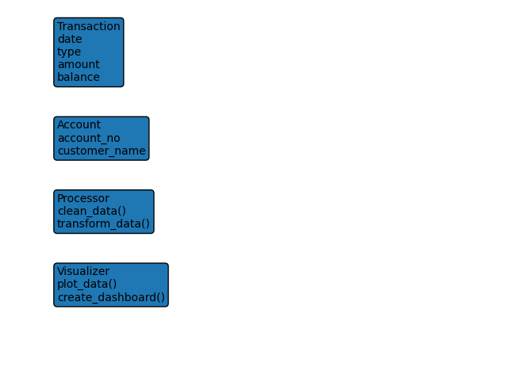
Explanation
The class diagram shows the structure of the system by representing different components as classes.
The Transaction class includes attributes such as date, type, amount, and balance, which define each transaction.
The Account class contains account related details such as account number and customer information.
The Processor class is responsible for cleaning and transforming the data.
The Visualizer class handles the creation of charts and dashboards.
These classes are connected logically. Transaction data is linked with account details, processed by the processor, and then passed to the visualizer. This defines how the system is organized internally.

Sequence Diagram
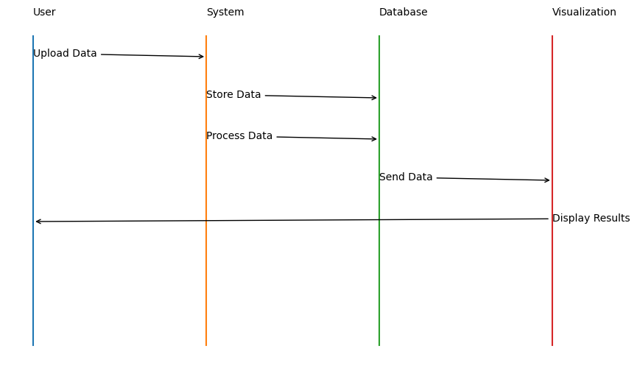
Explanation
The sequence diagram explains the interaction flow step by step.
The process begins when the user uploads the transaction data. The system then stores the data in the database. After storing, the system processes the data to clean and structure it. The processed data is sent to the visualization component, where charts and dashboards are generated. Finally, the results are displayed to the user.
This diagram clearly shows the order of operations and how each part of the system communicates in sequence.

Use Case Diagram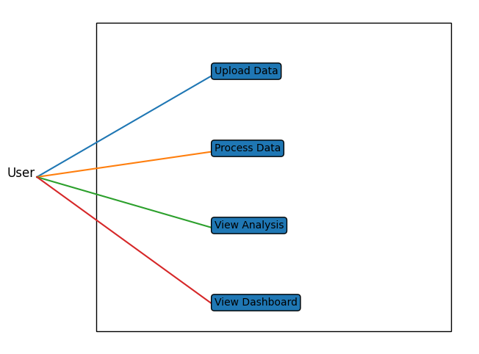
Explanation
The use case diagram represents how the user interacts with the system.
The main actor in the system is the user. The user performs actions such as uploading transaction data, processing the data, viewing analysis results, and accessing dashboards. These actions represent the core functionalities provided by the system.
The system handles these actions by processing the data and generating outputs. The interaction is simple and direct, where the user provides input and the system responds with results. Each use case highlights a specific operation that the system performs.

Outputs
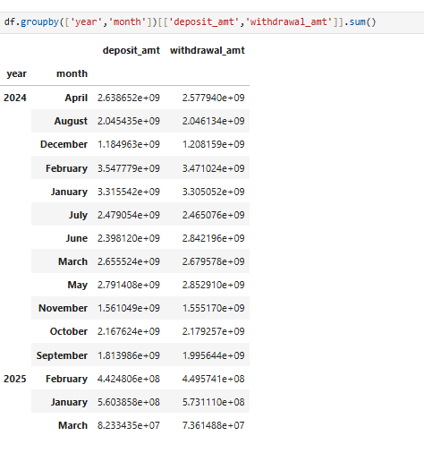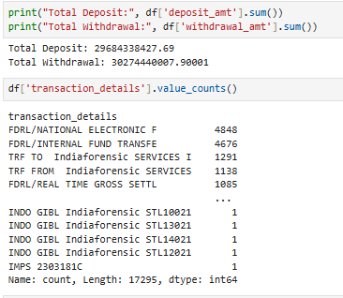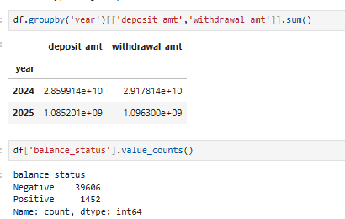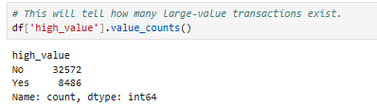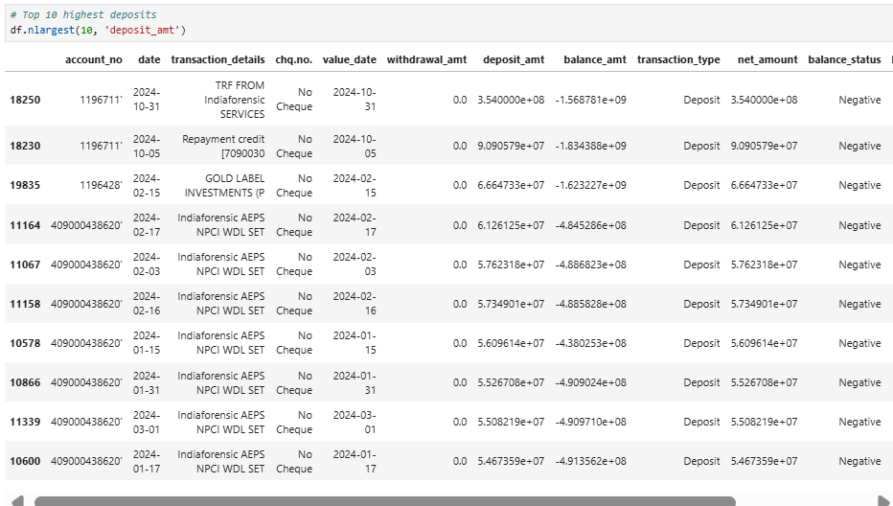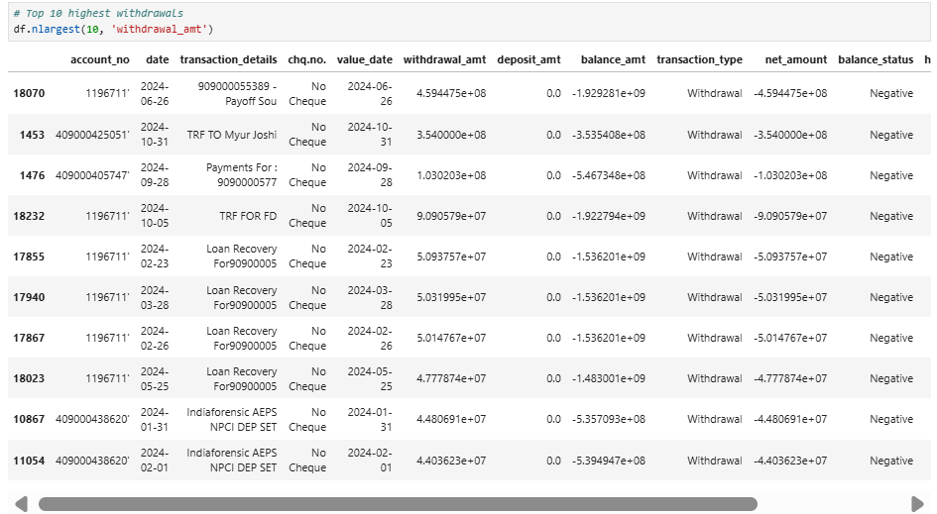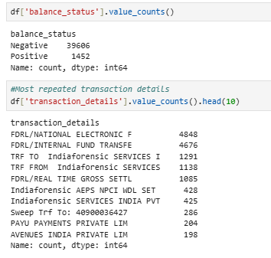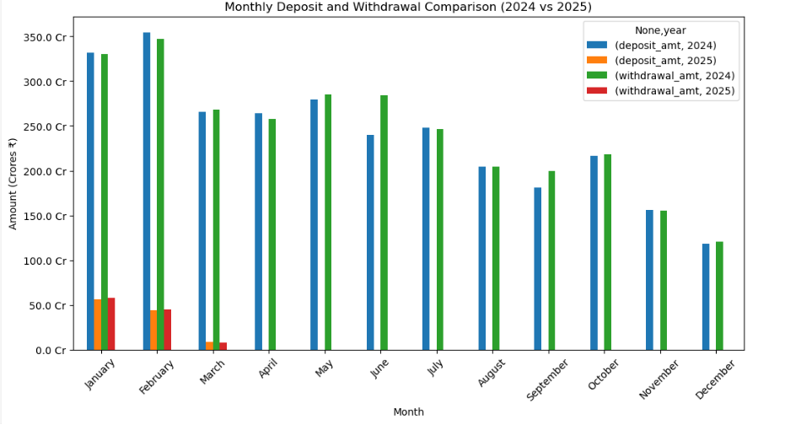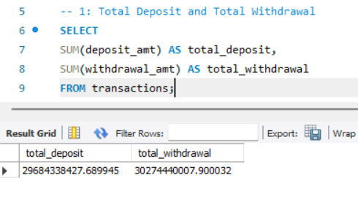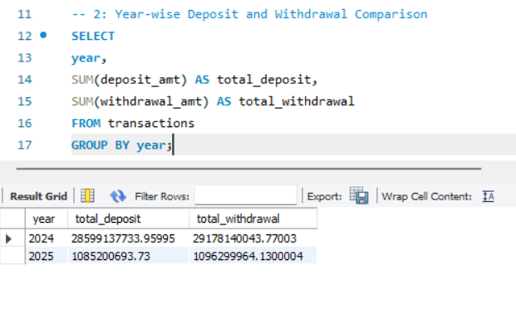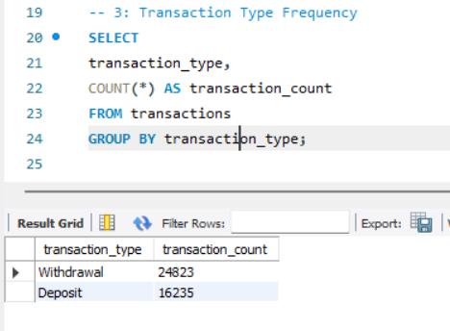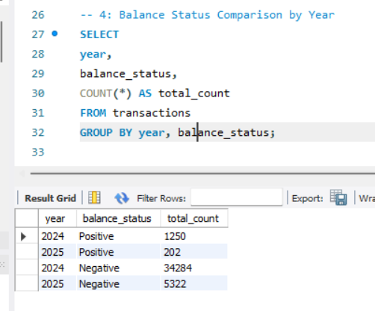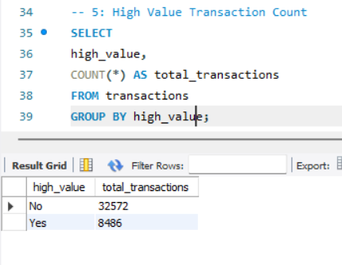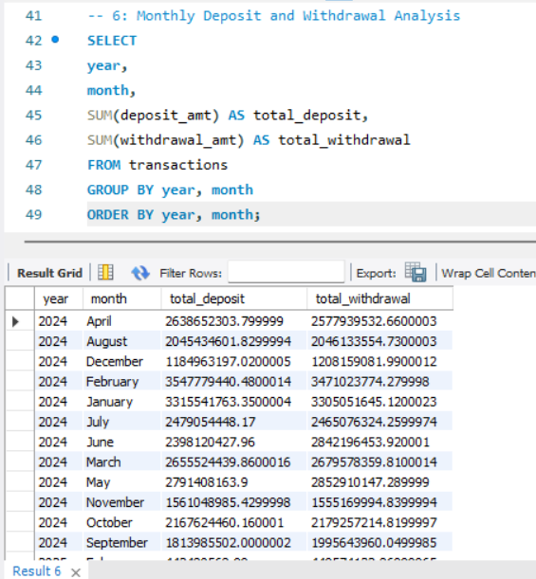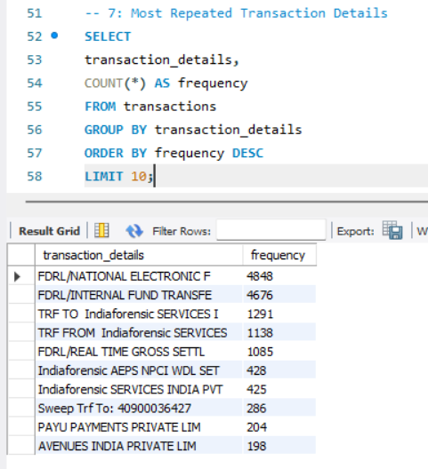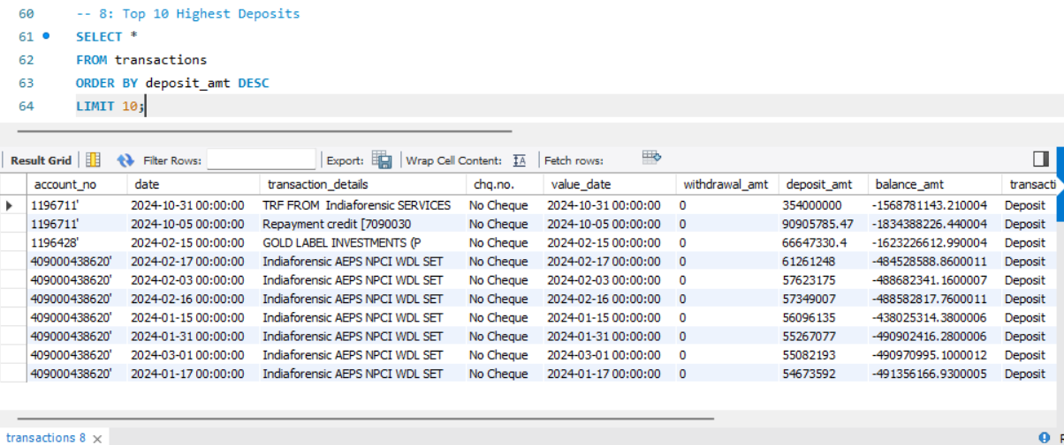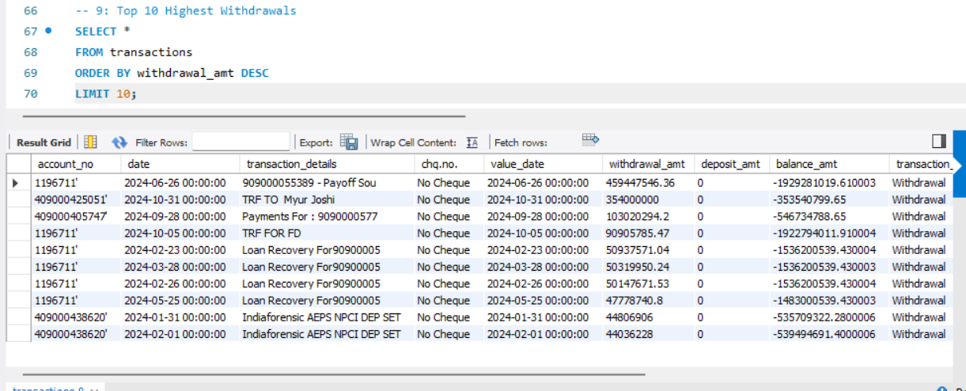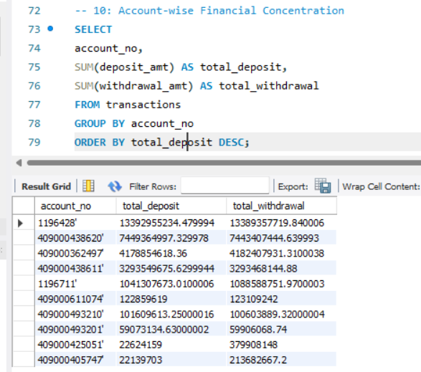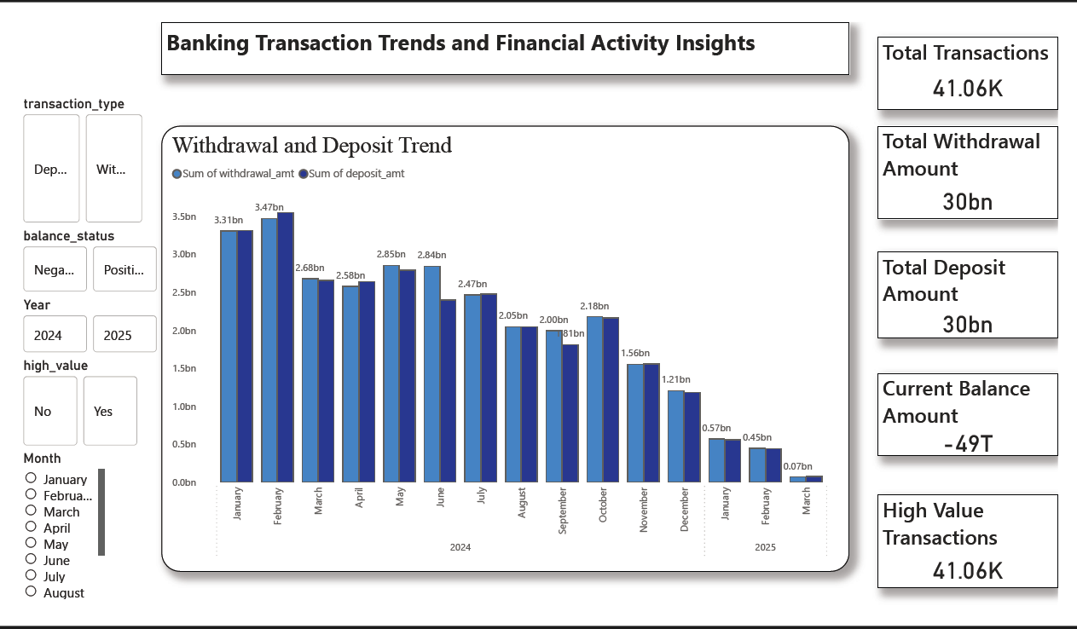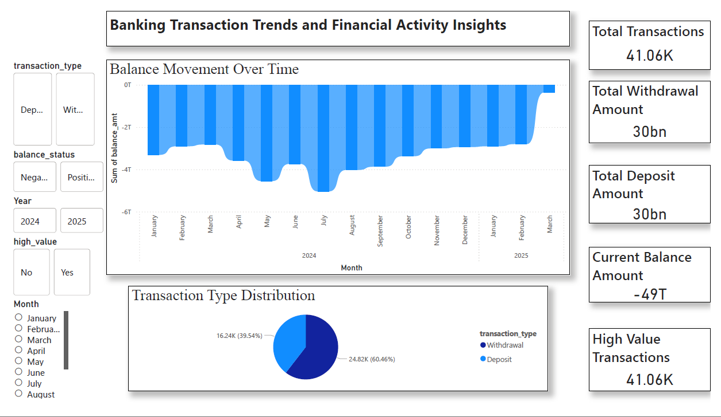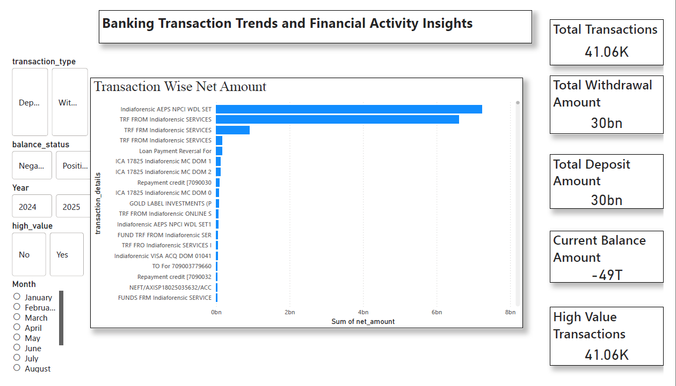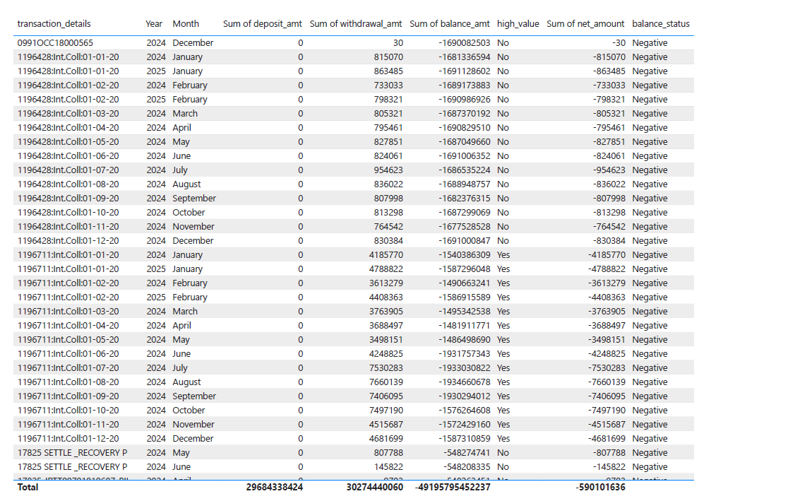
14. OUTPUT AND ANALYSIS
The outputs generated from the analysis provide a clear view of how banking transactions are performed over time and how financial activity is distributed within the account. The visualizations collectively show the relationship between deposits, withdrawals, and balance changes. From the results, it is evident that deposits occur at specific intervals and lead to a sudden increase in balance, while withdrawals happen more frequently and gradually reduce the balance. This creates a repeating pattern of rise and fall, reflecting typical financial behavior.
The trends observed across different time periods indicate that transaction activity is not uniform. Certain periods show higher activity levels, which may be linked to regular financial events such as income credits or major expenses. Daily and monthly patterns highlight that transactions are often clustered around specific dates rather than being evenly spread. This helps in identifying peak activity periods and understanding how financial operations vary over time.
The distribution of transaction amounts shows that most transactions fall within a moderate range, while a few high value transactions have a significant impact on the overall balance. These high value transactions play an important role in shaping the financial position of the account. The comparison between deposits and withdrawals further shows how money flows in and out, providing insight into whether the account maintains stability or experiences more outflow.
Overall, the analysis reveals that banking transactions follow a structured and predictable pattern. The outputs make it easier to understand financial behavior, track balance movements, and identify key trends in transaction activity. This provides a meaningful interpretation of the data and supports better understanding of how accounts are managed over time.

15. OVERALL CONCLUSION
This project provides a comprehensive understanding of how banking transaction data can be effectively analyzed to uncover meaningful patterns and insights related to financial activity. By working with detailed transaction records that include deposits, withdrawals, and balance updates, the project demonstrates how raw data can be transformed into a structured and analysis ready format. The overall process highlights the importance of organizing and interpreting financial data in a systematic manner to gain a clear picture of how accounts are managed over time.
One of the key observations from the analysis is the cyclical nature of financial transactions. Deposits typically occur at specific intervals and result in a noticeable increase in account balance. These inflows are often followed by a series of withdrawals, which gradually reduce the balance. This repeating pattern reflects real world financial behavior, where income is received periodically and expenses are incurred on a regular basis. The balance trend clearly shows this rise and fall pattern, providing insight into how funds are utilized within the account.
Another important finding is that transaction activity is not uniformly distributed across all time periods. Instead, transactions tend to be concentrated around certain days or months. These periods of higher activity may correspond to routine financial events such as salary credits, bill payments, or other recurring transactions. By identifying these patterns, it becomes easier to understand when financial activity is at its peak and how it varies over time. This time based analysis adds depth to the understanding of transaction behavior.
The analysis of transaction amounts reveals that most transactions fall within a moderate range, indicating regular day to day financial activity. However, a smaller number of high value transactions have a significant impact on the account balance. These transactions stand out clearly and often represent important financial events such as large deposits or major expenses. Their influence on the overall financial position of the account highlights the importance of identifying and analyzing such transactions separately.
The comparison between deposits and withdrawals provides valuable insight into the overall financial flow within the account. Deposits represent incoming funds, while withdrawals indicate outgoing expenses. By analyzing these two components together, it becomes possible to assess whether the account maintains a balance over time or experiences higher levels of spending. This comparison is essential for understanding financial stability and usage patterns.
A major strength of this project lies in its structured approach to data handling and analysis. The process begins with raw data collection and moves through stages of cleaning, organization, and transformation. By ensuring that the data is accurate and consistent, the project establishes a strong foundation for reliable analysis. The addition of derived fields such as transaction type, net amount, and time based attributes further enhances the dataset and makes it more suitable for detailed examination.
The use of structured querying techniques plays a significant role in extracting meaningful information from the dataset. By applying queries, it becomes possible to calculate totals, identify trends, and retrieve specific insights efficiently. This approach simplifies the analysis of large datasets and ensures that relevant information can be accessed quickly. It also improves the accuracy of results by reducing manual calculations.
Visualization is another important aspect of the project, as it helps in presenting the analyzed data in a clear and understandable format. Charts and dashboards provide a visual representation of transaction patterns, balance trends, and financial activity. These visual outputs make it easier to interpret complex data and communicate insights effectively. Instead of relying only on numerical values, users can quickly identify patterns and trends through graphical representations.
From a practical perspective, the project offers several benefits. It improves the efficiency of handling transaction data by reducing manual effort and streamlining the analysis process. It also enhances accuracy by minimizing errors through proper data preprocessing and structured analysis. The ability to quickly access insights and visualize data makes the system more user friendly and effective for understanding financial activity.
In terms of real world application, the approach used in this project can be applied to various financial analysis scenarios. It can help in monitoring account activity, understanding spending behavior, and tracking balance changes over time. The insights derived from such analysis can support better financial planning and decision making. It also provides a foundation for managing larger datasets and performing more advanced analysis in the future.
The project also contributes significantly to learning and skill development. It provides hands on experience in handling real world data and applying data analytics techniques in a structured manner. Key concepts such as data cleaning, transformation, querying, and visualization are explored in detail. This helps in building a strong understanding of how data analytics is applied in practical scenarios, particularly in the context of financial data.
Another important learning outcome is the ability to interpret data effectively. The project emphasizes not just performing analysis but also understanding and explaining the results. By examining patterns and trends, it becomes possible to draw meaningful conclusions and provide insights that are relevant and useful. This skill is essential for working with data in any domain.
Overall, the project demonstrates how a simple dataset can be transformed into a valuable source of information through systematic analysis. It highlights the importance of organizing data, applying structured methods, and presenting results clearly. The findings show that banking transactions follow predictable patterns that can be analyzed to gain a deeper understanding of financial behavior.
In conclusion, this project successfully achieves its objective of analyzing banking transaction data and extracting meaningful insights. It combines data preprocessing, structured analysis, and visualization to provide a complete view of financial activity. The approach ensures accuracy, efficiency, and clarity, making it a practical and effective method for understanding transaction patterns. The knowledge and experience gained from this project can be applied to other data analysis tasks, making it a valuable learning experience as well as a useful analytical framework.

